**SRS Documentation**

**Publishing Review Management**

**(Assignment 1)**

Prepared by

**DEBOPRIYO GHOSH**

**SAIKAT JANA,**

**MOUSUMI MONDAL,**

**SARADINDU RANA,**

**B.Tech., Sem - V, Group- 1**

Dated: 20 /01/2021

Contents

* 1. **Assignment 1**

1. Data Requirement
2. Assumptions
3. Entity - Relationship Diagram
4. Relationships
5. Relational Schema
6. Normalization of Relational Schema

**Assignment 1**

**Two case studies are given below. You have to analyse the situation; prepare the requirements (functionalities i.e. the probable reports that may be needed by consumers); accordingly decide the data requirement, express it through E-R data model. clearly state the assumptions, if any.**

**Case Study 2:**

**—Publishers publish many different types of professional journals and books. Some publishers only publish books, some journals and some both. No book or journal is published by more than one publisher. An author may write either books, journal articles, or both. A journal typically contains several articles, each one written by one or more authors. No article appears in more than one journal. Any journal may have one or more abbreviations, or none.**

**—Every book or article is reviewed by several professionals in the field who may or may not be authors as well. Of course, an author never reviews his or her own book article. Each book reviewer and author works for and is paid by a single publisher. Article authors and reviewers are not paid, however and thus article reviewers are not book reviewers. Authors and reviewers who are not paid by a publisher are known as independent professionals.**

1. **Data Requirement**

**BOOKS**: Every book has an unique Bid which is book id , Bname which is name of thebook , Price , Paid which is the amount paid by publisher to author for the book.

**PUBLISHERS**: Every publisher has specific publisher id (Pub_id) , name of thepublisher (Pub_name), Address and Phone number.

**JOURNALS**: Each journal has unique journal id (Jid) ,name of the journal (Jname),No_art which determine number of article contains by that journal and price.

**ARTICLES**: Every article contains individual article id (Art_id) , name of the article(Art_name).

**ABBREVIATION**: Every abbreviation of a journal has unique Abb_id which is id ofabbreviation and Date in which abbreviation is published.

**AUTHORS**: Each author has unique id (Aid) , name(Aname) ,address and phonenumber.

**PROFESSIONAL**: Every professional has specific id (Pro_id), name (Pro_name).

1. **Assumption**
   1. This a simpler version of a Publishing review system. Many improvements can be done to this system to meet the requirements of real life problems.
   2. An author can write multiple papers. It is not mandatory that an author can write only one paper at one time but an author must be part of at least one paper.
   3. When multiple reviewers are reviewing a paper, the data from each reviewer is collected and formulated to produce a final review of the paper.
   4. A reviewer may have multiple field of interest. The paper which he/she will review must belong from his/her preferred field of interest.
   5. When a paper contains multiple authors, one of the author is made the contact author. Now this contact author cannot be made the contact author of another group of authors.
   6. An author writes books and a reviewer reviews books for only one publisher, so they are paid by only that publisher.
   7. Article authors and reviewers are not paid. Authors and reviewers are not paid called independent professional.
   8. An author may or may not be a professional.
   9. One publisher may publish many different types of professional journals and books.
   10. One author may write journal article, books or both. One journal contains several article. Each article written by one or more author.
   11. A journal may have several abbreviations.
   12. Professionals review books and articles.
2. **Entity Relationship Diagram A. Diagram**

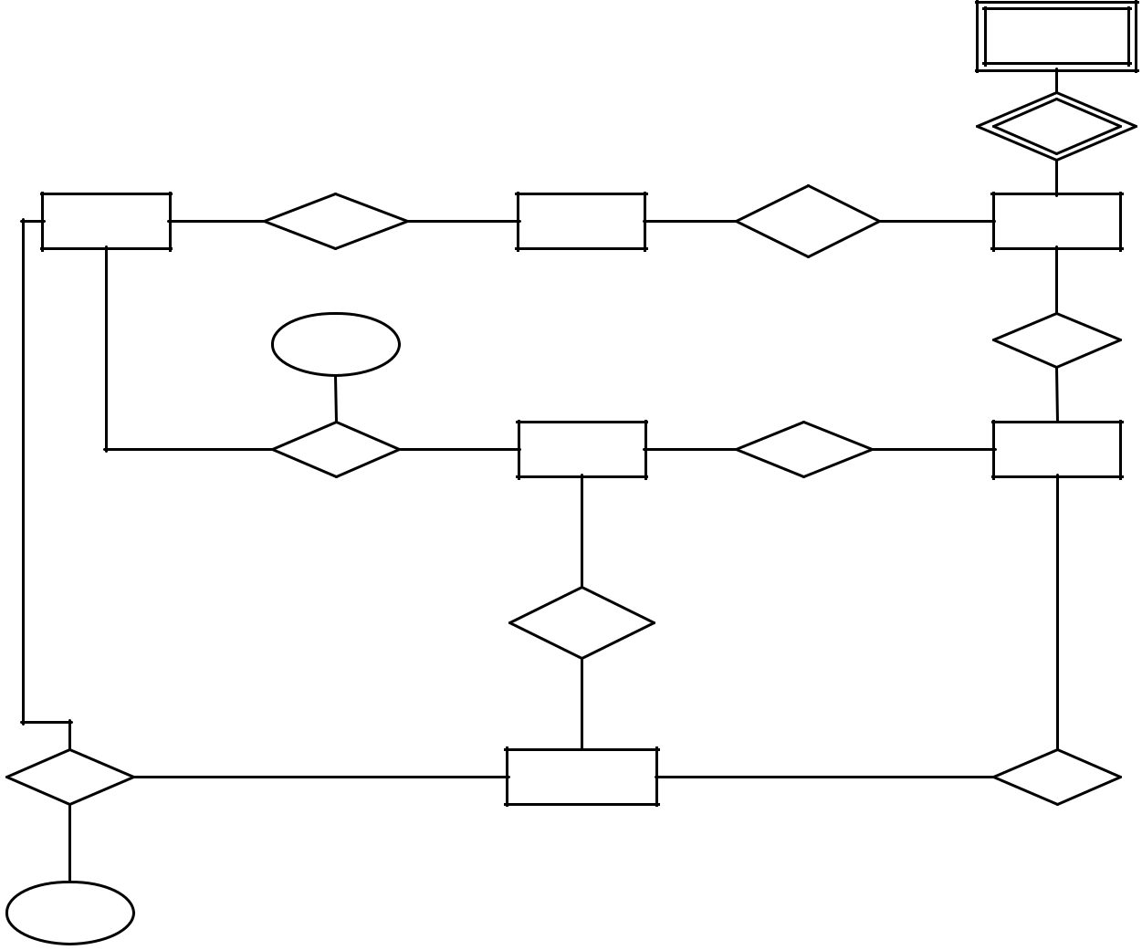

|  |  |  |  |  |  |
| --- | --- | --- | --- | --- | --- |
|  |  |  |  | **ABBREVIATION** |  |
|  |  |  |  | (0,N) |  |
|  |  |  |  | **HAVE** |  |
|  |  |  |  | (1,1) |  |
|  | (0,N) | (1,1) | (1,1) | (0,N) |  |
|  |  |  |  |
| **BOOKS** | **PBOOK** | **PUBLISHERS** | **PJOURNAL** | **JOURNALS** |  |

(1,1)

(0,N) **PAID** **CONTAINS**

(1,N)

|  |  |  |  |
| --- | --- | --- | --- |
| (1,1) |  | (1,M) | (0,N) |
| **WBOOK** | **AUTHORS** | **WARTICLE** | **ARTICLES** |

(0,1)

|  |  |  |
| --- | --- | --- |
| **ARE** | (0,N) |  |
|  |  |

|  |  |  |  |
| --- | --- | --- | --- |
| (0,N) | (0,1) |  |  |
| (1,M) | **PROFESSIONAL** | (1,M) |  |
| **BREVIEW** | **AREVIEW** |  |

**PAID**

1. **Description**
   1. In this diagram there is a weak entity “abbreviation” which is connected with journal through “have” relationship.
   2. The other entities are Books, Publishers, Journals, authors, articles, professional.
   3. Publishers publishes books and journals so “journal” and “book “is connected with *pjournal* and *pbook* relationship respectively.

4.Authors writes books and articles so “books “and “article” are connected with *wbook* and *wartricle* relationship respectively with “author”.

* 1. a “journal” contains many articles so journal and articles are connected with one to

many relationship “contains”.

1. Professional reviews books and article so entity “books” and “articles” are connected with “professional” through “breview” and “areview” relationship.
2. Some authors may be professionals so they are connected with “professional” with “are” relationship.
   1. Book writers and reviewers are paid so “wbook” and “breview” each has an attribute called “paid”.
3. **Attributes**

BOOKS: {Bid , Bname , Price}

JOURNALS: {Jid , Jname ,No_art ,Price}

PUBLISHERS: {Pub_id , Pub_name , Address, Phone}

ARTICLES: {Art_id , Art_name}

AUTHORS: {Aid , Aname ,Address , Phone}

ABBREVIATION: {Abb_id , Date}

PROFESSIONAL: {Pro_id , Pro_name}

1. **Relationships**
   1. Abbreviation is weak entity because it cannot be uniquely identified by its attributes alone. An abbreviation does not exist without journal.
   2. Author-professional (1:1) comprises.
   3. Publisher-book and publisher-journal (1:N) comprises.
   4. Author-book (1:N) comprises and author-article (M:N) holds. Journal-article (1:N) comprises.
   5. Journal-abbreviation (1:N) holds.
   6. Professional-books and professional-article (M:N) comprises.
2. **Relational Schema**

**BOOKS: {Bid, BName, Price, FOREIGN KEY(Pub_Id) REFERENCES PUBLISHERS(Pub_Id), FOREIGN KEY(AId) REFERENCES AUTHORS(AId), A_Paid}**

**PUBLISHERS: {Pub_Id, Pub_Name, address, Phone}**

**JOURNALS: {JId, JName, No_Art, Price, FOREIGN KEY(PId) REFERENCES PUBLISHERS(PubId)}**

**ABBREVIATION: {Abb_Id, FOREIGN KEY(JId) REFERENCES JOURNALS(JId), Date}**

**ARTICLES: {Art_Id, Art_Name, FOREIGN KEY(JId) REFERENCES JOURNALS(JId)}**

**AUTHORS: {Aid, Profid, AName, Address, Phone}**

**WRITEARTICLE: { FOREIGN KEY(AId) REFERENCES AUTHORS(AId), FOREIGN KEY(Art_Id)**

**REFERENCES ARTICLES(Art_Id)}**

**BOOKREVIEW: { FOREIGN KEY(ProfId) REFERENCES PROFESSIONAL(ProfId), FOREIGN KEY(BId) REFERENCES BOOKS(BId), paid}**

**ARTICLEREVIEW: { FOREIGN KEY(ProfId) REFERENCES PROFESSIONAL(ProfId), FOREIGN KEY(Art_Id)**

**REFERENCES ARTICLES(Art_Id)}**

1. **Normalization of Relational Schema**

**BOOKS (Bid , Bname , Price , Pub_id , Aid, A_paid)**

Bid->{Bname, Price , Pub_id , Aid, A_paid }

Bid is the candidate key.

There is no multi valued attribute so the table is in 1nf.

Bid is the primary key so there is no partial dependency, so the relation is in 2nf.

The table is in 3nf as there is no transitive dependency.

**JOURNALS (Jid , Jname , Price, No_art , Pub_id}**

Jid->{ Jname , Price, No_art , Pub_id }

Jid is the candidate key.

There is no multi valued attribute so the table is in 1nf.

Jid is the primary key so there is no partial dependency, so the relation is in 2nf.

The table is in 3nf as there is no transitive dependency.

**ARTICLES (Art_id , Art_name ,Jid)**

Art_id ->{ Art_name ,Jid }

Art_id is the candidate key.

There is no multi valued attribute so the table is in 1nf.

Art_id is the primary key so there is no partial dependency, so the relation is in 2nf.

The table is in 3nf as there is no transitive dependency.

**AUTHORS (Aid , Aname ,Address , Phone)**

Aid->{ Aname ,Address , Phone }

Aid is the candidate key.

There is no multi valued attribute so the table is in 1nf.

Aid is the primary key so there is no partial dependency, so the relation is in 2nf.

The table is in 3nf as there is no transitive dependency.

**PUBLISHERS (Pub_id , Pub_name , Address, Phone)**

Pub_id->{ Pub_name , Address, Phone}

Pub_id is the candidate key.

There is no multi valued attribute so the table is in 1nf.

Pub_id is the primary key so there is no partial dependency, so the relation is in 2nf.

The table is in 3nf as there is no transitive dependency.

**PROFESSIONAL { Pro_id , Pro_name ,Aid}**

Pro_id ->{ Pro_name ,Aid}

Pro_id is the candidate key.

There is no multi valued attribute so the table is in 1nf.

Pro_id is the primary key so there is no partial dependency, so the relation is in 2nf.

The table is in 3nf as there is no transitive dependency.

**ABBREVIATION {Abb_id, Jid, Date}**

Abb_id ->{ Date ,Jid }

Abb_id is the candidate key.

There is no multi valued attribute so the table is in 1nf.

Abb_id is the primary key so there is no partial dependency, so the relation is in 2nf.

The table is in 3nf as there is no transitive dependency.

**WARTICLE {Aid , Art_id }**

Aid , Art_idis a composite primary key.

There is no multi valued attribute so the table is in 1nf.

There is no partial dependency, so the relation is in 2nf.

The table is in 3nf as there is no transitive dependency.

**AREVIEW {Pro_id , Art_id }**

Pro_id , Art_idis a composite primary key.

There is no multi valued attribute so the table is in 1nf.

There is no partial dependency, so the relation is in 2nf.

The table is in 3nf as there is no transitive dependency.

**BREVIEW {Pro_id , Bid , Paid }**

{Pro_id , Bid} -> Paid

Pro_id , Bid is the candidate key.

There is no multi valued attribute so the table is in 1nf.

Pro_id , Bid is the primary key so there is no partial dependency, so the relation is in 2nf.

The table is in 3nf as there is no transitive dependency.